# Game Design Document

**Game Concept**

It’s casual, 2D, “Frogger” style, where the player controls a Valkyrie who needs to reach treasure and avoid dragons.

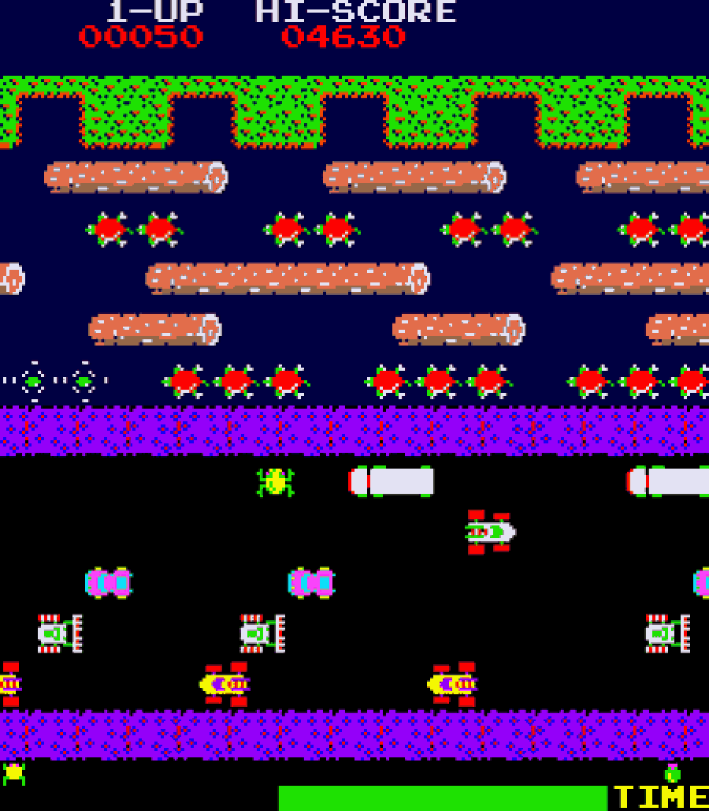

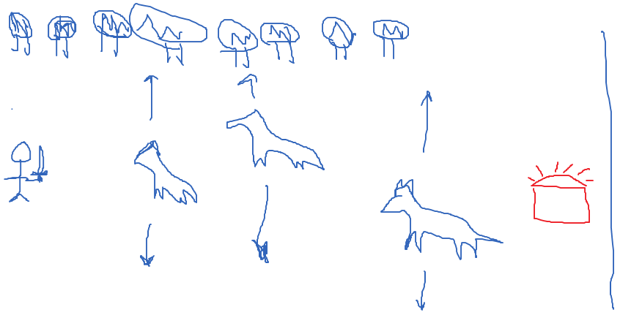

**Target Platforms**

* Cross-Platform: for desktop and mobile
* Web Brower Game

**UI / Player Controls**

* Mouse Click / Touch Screen
* When the player clicks /touches the screen, the character moves forward

**Game Mechanics**

* Dragons moving up and down (bouncing movement)
* If the player is hit by a dragon, the game restarts
* The player wins if they reach the treasure. Then the game will restart
* The player can only move in one direction

**Assets**

* Style: pixel art, 8-bit style, retro RPG
* Sprites
* Background
* Player
* Enemy
* Treasure